New Research: Steroids Hammer Stem Cells
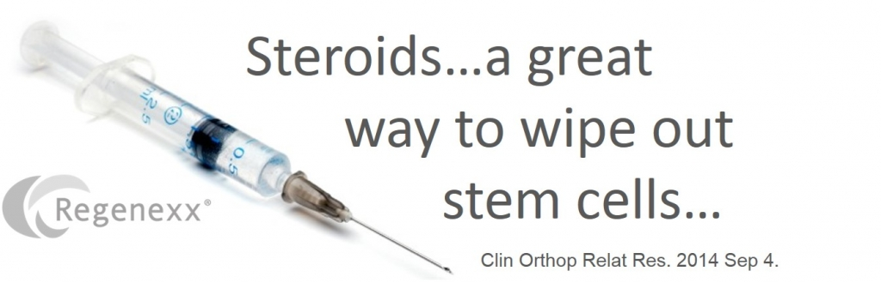

Steroids are widely used in Orthopedic care like water, sprinkled here and there for good measure in arthritis and surgical procedures alike. We’ve known for sometime that these high dose steroids are horrible for cartilage and other cells, but there hasn’t been much published on how they impact stem cells. Now a new study adds to the research base and it shows that steroids wipe out stem cells.
The steroid craze began in the 1950s with the isolation of cortisone from the adrenal gland. The drug was initially expensive, but cheaper synthesis methods helped the price to drop from $200 a gram to less than fifty cents a gram by 1980. The steroids we’re talking about here are corticosteroids, cousins of the type of steroids body builders use (anabolic steroids). Corticosteroids like cortisone are potent anti-inflammatories, but they also inhibit healing. In addition, as cellular biology became more common in the 90s, scientists began to see that the milligram doses that were produced by these cheap synthesis processes where about 1,000,000 times too high for the body’s cells. In fact, your cells are used to seeing naturally produced corticosteroids in the nanogram to picogram range. How much is a nanogram when compared to the milligram dose commonly used in medicine? If the height of a matchbook represented a nanogram, the height of the Empire State Building would be one milligram!
The big problem in modern orthopedics is that the message that scientists have been publishing since the 1990s has yet to make it to the average practitioner. So the average physician injecting steroids into joints or epidurals or peddling steroid pills for acute back pain isn’t aware how damaging these high doses are to the body. As one example, a recent study showed a frightening increase in a serious bone disease called ostenecrosis with even short-term use of oral steroids. In fact, the average doctor who has taken a weekend course on how to inject stem cells also isn’t aware of this issue. To expand on that last point, how damaging are steroids to stem cells?
The new research looked at mesenchymal stem cells, the type most commonly used to treat orthopedic conditions. The cells were exposed to various commonly available commercial types of steroids at different doses. For betamethasone and triamcinolone, two commonly used steroids in orthopedics, just 25% and 75% of the usual clinical dose wiped out all stem cells. It took the full strength of dexamethasone and methylprednisolone to wipe out all cells.
The upshot? The usual doses of steroids kill stem cells. Having said that, we routinely see physicians who don’t know any better using steroids in close proximity to stem cells, all but guaranteeing that the stem cells will be DOA!

